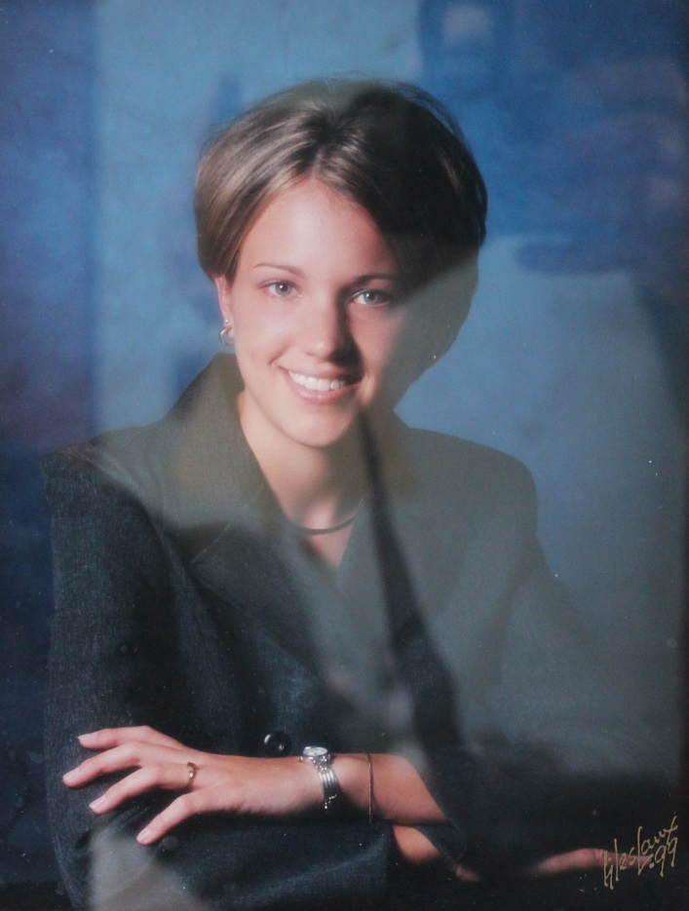

**Amanda Leigh List – 1998**

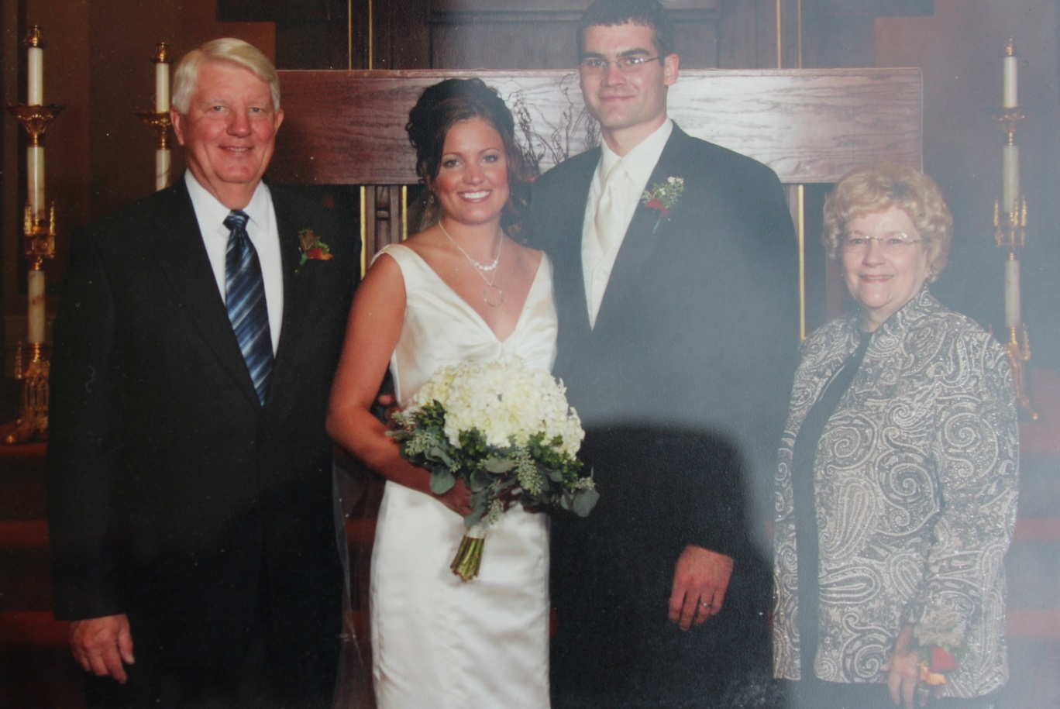

**David Wolfe List, Amanda List Knapke, Ben Knapke, Carolyn Huffer List - Oct 2006**